Groupwork Questionnaire Results
This survey was conducted in late 2008/early 2009. It surveyed just over 100 students from a variety of courses and levels of study. Students were asked to complete a short questionnaire about their experiences of working on a group project with other students. The survey is at the end of this report.

How much experience have you had of working with a group/team on a project before now?
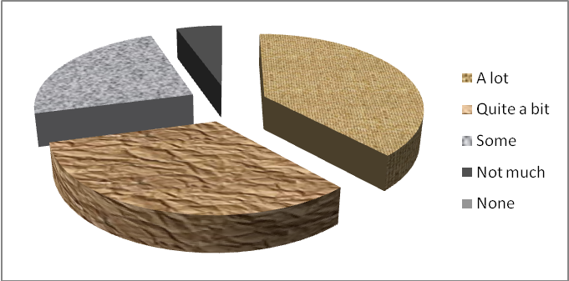

If you have worked in a group before, how did you find it?
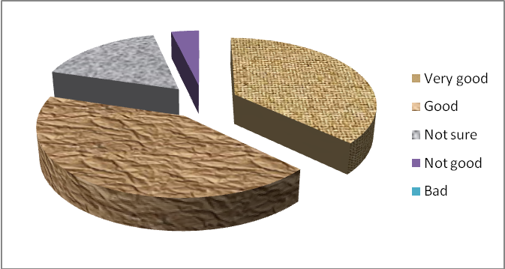

What problems (if any) did you have with working in a group?
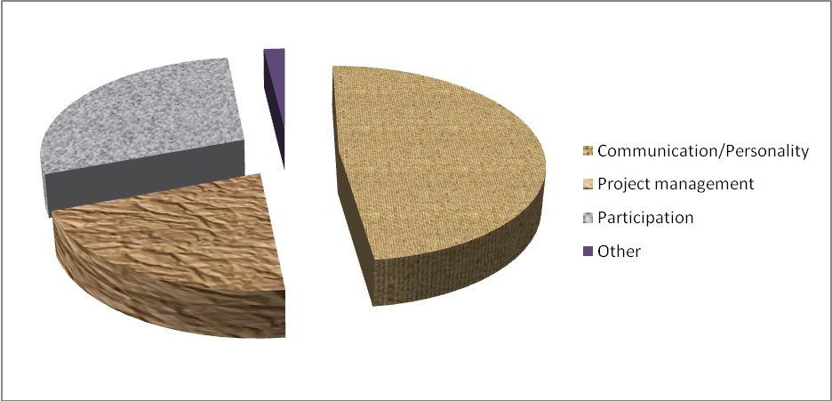

What resources / support services do you think might be useful?
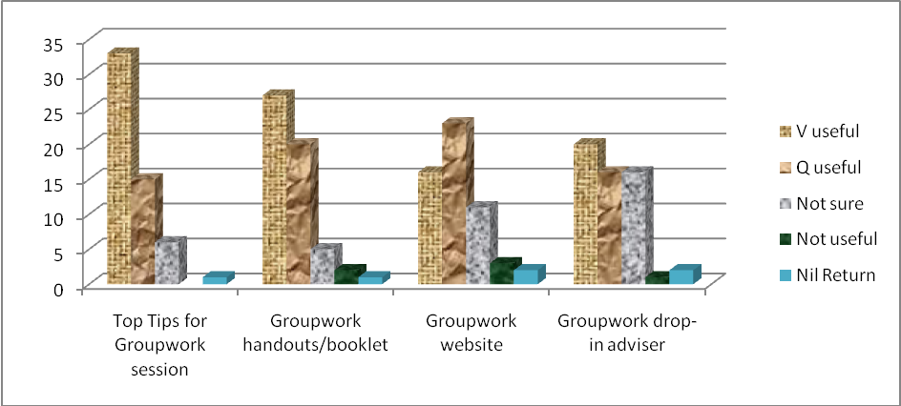

Qualitative Feedback
Groupwork Experience
- I have done a lot of groupwork in college and other community centres.
- Helps to build teamworking skills.
- Teamwork is important in a hospital environment.
- Work on a lot of service development in my team and commissioning of services.
- It requires a lot of understanding and tolerance to make a team successful.
- I’ve worked in teams during basketball games, at work and at some times university.
- I have worked as a team member in my group project in university.
- I have worked in an organisation with a need to work in a team for quite a long time.
- At least once a semester.
- It was OK.
- Once in my first year, once in my second year and once in my third. On my work placement in community pharmacy.
- Classwork, jobs, outdoor activities.

How did you find working in a group?
- It depends if everyone pulls their weight.
- Interesting to hear everyone’s ideas.
- Enjoy it – feel able to adapt to different teams when on duty.
- Good for brainstorming and sharing skills and thoughts.
- Motivational – I find it motivating being a team leader or part of a group.
- Getting ideas from different people.
- Share ideas.
- People got on so made it worthwhile.
- More opinions and choices.
- Synergy was the secret – team spirit.
- Most group members were reluctant to contribute which was not very encouraging.
- I enjoyed working with a team.
- All the team enjoyed working with each other and welcome the possibility to work again.
- Sometimes had good experiences, while some other times the opposite thing.
- Some members had longer than other members.
- Some groups are effective and some slow the pace of the work.
- Good – particularly in small groups (up to 5 or 6).
- Some were quite bad and some quite good.
- Full of challenges.
- It’s always difficult to keep the group in a united form and hard work really to work under someone if he/she is not a good leader.

- Fairly good and effective depending on the effort and input that group members put in / contribute towards the achievement of goals.
- I enjoy working with people and communicating ideas.
- Able to learn from other people’s experiences and knowledge.
- Splitting the work up effectively allows more to be achieved in a shorter space of time.

Problems in Groupwork
Participation
- Not everyone joining in and taking part.
- Some people won’t contribute or work together.
- Lazy group members, members who aimed too low.
- Some people were not motivated to work properly
- In my last group work we had some problems with one of the members. The guy didn’t get in touch with the group until the last moment and after that pretended himself as a part of the group work.
- Sometimes some of the members of the group didn’t do the work they were responsible for which brought the whole group down and meant that some members of the group had to do more than their fair share of work.
- Some people did not contribute much to the group and had to be forced to do work.
- It basically depends who you have in your group with you – some people put more work in than others!
- I am just lazy!
- Some group members do not put in effort.
- Some group members expect you to do all the work and then assign their names on it.
- Trying to get everyone to participate.
- Reliability
- Sometimes you may find group activity slow in participation from other members. Maybe sometimes people are not familiar with one another.
- It can be difficult contacting others at times.
15

Communication/Personality issues
- None really, besides if one person within the group takes the most control.
- Everyone wanted to be in charge sometimes, but overall it’s a great experience.
- Difference of opinions and ways of working.
- Sometimes feel people pulling in opposite directions, not thinking of peoples’ feelings. Final aim is similar, but different strategies to get there.
- Personality clashes.
- Very rarely – disagreements.
- Sometimes you get people who don’t want to fit into the team.
- Dealing with “difficult” people.
- Some people try to put others down, are negative.
- Sometimes all members don’t act responsibly.
- Different members have different interests and natures.
- The problem was that I had to keep changing the work that I was doing because some members of the group were not satisfied with it. I had to keep changing what I was working on.
- Being able to accept contrary conflicting views and striking a balance that effectively mitigated circumstances.
- Some members might be too bossy, not showing interest in team work.
- General conflicts – 2 people trying to lead the group.
- Everyone wants to be a leader/spokesperson.
- Lack of communication. Different view points, usually difficult to get people together on one point or issue. It’s very difficult to work under a leader.
- Lack of communication
- The larger the group, the more difficult it can be to confidently express an opinion or idea.
- People who knew each other outside the group stuck together in decision making.
- Friendship in group can lead to bias. Different opinions in group.
- Some people would always try to take over even though they are not the only ones that are capable.
- On my work placement, one of the group members did certain activities one way and would not adjust.
- Working with different people with different ideas (sometimes those ideas were outside the challenge’ s scope).
- People misunderstanding what is expected of them, so the group didn’t function very well.
25
Project Management
- Not everybody knew what they were doing, so the group did not work together as well.
- Different perceptions of goals
- Members who didn’t understand what the project was about or knew what they were doing.
- Sometimes need more time to think before decisions are taken.
- Different ideas or ways to do it.
- Following on from decisions made, implementing objectives can sometimes be difficult in the work environment.
- inadequate eg timings and meeting deadlines.
- Lack of group structure.
- Lack of team working or concentration.
- Low degree of co-operation.
- Also often people want to approach tasks in different ways.

11
Other
- Unexpected events.
1

Other Support Services
- Group practice
- Learning discussion
- This workshop is useful, but it would be better to arrange at least one each month.
- To give tips about giving a group presentation.
- Getting a point through effectively.
- Actually I thought this would be about teamwork at work which might be a bit different in some aspects.
- More groupwork sessions can be arranged with different tasks and with different people with different backgrounds.
- Support services not needed in my experience, but some tips could be useful.
- Please help!

Student Development Group Work Questionnaire
1. How much experience have you had of working with a group/team on a project before now?
Please circle the statement most relevant
1. A lot 2. Quite a bit 3. Some 4. Not much 5. None
Comments …………………………………………………………………………………………………………………………...
………………………………………………………………………………………………………………………………………………..
2. If you have worked in a group before, how did you find it?
Please circle the statement most relevant
1. Very Good 2. Good 3. Not sure 4. Not Good 5. Bad
Comments …………………………………………………………………………………………………………………………...
………………………………………………………………………………………………………………………………………………..
3. What problems (if any) did you have with working in a group?
Please give a brief description
………………………………………………………………………………………………………………………………………………..
………………………………………………………………………………………………………………………………………………..
………………………………………………………………………………………………………………………………………………..
4. What support service(s) do you think might be useful in supporting you with group work?
Please tick.
Service | Very Useful | Quite Useful | Not sure | Not useful
Top Tips for Group Work session
Group Work Handouts/booklet
Group work website
Group Work drop-in advisor

Other (please detail)
………………………………………………………………………………………………………………………………………………..

